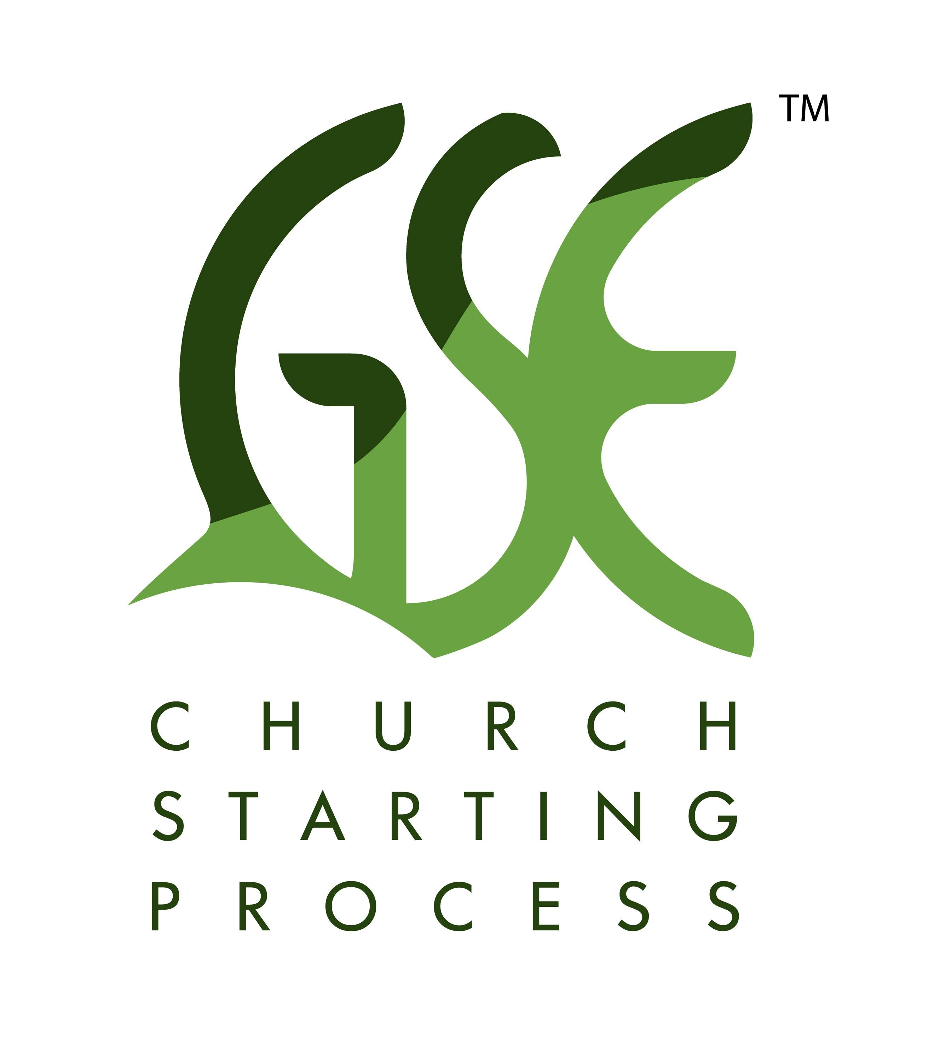
GSE Plant Training

G – Gatherer
S – Shepherd
E – Elder

A no cost, simple church starting process.

Our Six-Fold Focus on the GSE Plant Process

- Essence of GSE – Page 3

- Gatherer – Page 6

- Shepherd – Page 9

- Elder – Page 10

- Our metrics for biblical success – Page 10

- Connection: communication and coaching – Page 11

Our four key results or take aways from our time together about GSE:

- Church – what are we talking about? Cannot start it unless I know what it is.

*3/5 Focus and how it is our threshold definition of what we are doing:

2. GSE Process – we need to understand well who a Gatherer is; who a shepherd is and who the elder is – as we have this understanding we can seamlessly walk through this church starting process.

3. One a day regional vision – we need to be able to communicate and ‘see’ the one a day regional vision and hunger for Jesus Christ to do this in the USA like He is around the world.

4. Do it – we need to be able to have enough understanding through this class to overcome the barriers and risk blocks that abound in all church starting work.

- Essence of GSE:

*Overview of the process:

*Talking Point – from the GSE whiteboard video #1, what questions do we have?

*One a day regional vision:

Acts 16:5 - So the churches were being strengthened in the faith, and were increasing in number daily. (NASB)

*Talking point - from reading chapter 6 of Raising Rabbits not Elephants, what is the value of the regional vision:

*3/5 Focus of church:

Our threshold definition of church:

3/5 Focus of church
Who church is:

  - Focus on Jesus’s Mission – Matthew 28:16-20. (Jesus Christ focus)
  - Communing with God. (God the Father focus)
  - In Spiritual Community Together. (Holy Spirit focus)
What church does:
1. Worship – the simplest process of God becoming clearer to me (leitourgia word family).
2. Fellowship– the simple process of God’s people becoming relationally closer - (koinonia word family)
- Teaching – (didake/didasko word family):
- Preaching – (kerugma/kerusso word family):
- Serving – (diakonia/diakoneo word family):

From the GSE Whiteboard video and reading Gathering to Movement, chapter 3, what are our discussion points?

*GSE – the three people/roles – who are these people?

Gatherer: Person who shapes the culture of the New Church and creates movement of people into the New Church (hereafter NC).

Shepherd: Person who frames the NC’s sustainability and monitors her authenticity.

Elder: Person who expands trust both in the NC as well as in the NC’s region.

Talking point: What is missing so as to understand more clearly?

*Four other keys to consider:

1. GSE is a church STARTING process.

2. What is working in the field is:

-GSE processed ideas

-Non-directive coaching

3. Small beginnings:

Zechariah 4:10: For who has despised the day of small things? But these seven will be glad when they see the plumb line in the hand of Zerubbabel—these are the eyes of the Lord which range to and fro throughout the earth.” (NASB)

Matthew 13:31-32: He presented another parable to them, saying, “The kingdom of heaven is like a mustard seed, which a man took and sowed in his field; and this is smaller than all other seeds, but when it is full grown, it is larger than the garden plants and becomes a tree, so that the birds of the air come and nest in its branches.” (NASB)

Isaiah 60:22: “The smallest one will become a clan,
And the least one a mighty nation.
I, the Lord, will hasten it in its time.” (NASB)

4. Why GSE processing works: Both natural gifting and spiritual gifting from God.

Discussion point:

2) Gatherer: Person who shapes the culture of the NC and creates movement of people into the NC.

*The two key focus points of the Gatherer:

1. Shapes culture of NC:

2. Creates movement of people into the NC:

*Biblical exegesis on the Gatherer:

*From the videos – what other questions do you have?

See:
-John 1:35-42

-John 1:43-51

-Mark 1:40-45

-Mark 5:18-20 (7:32 then 8:1 - the influence of the demoniac as a Gatherer leading to the feeding of the 4,000 in Decapolis)

-Luke 5:27-32

-John 4

-Matthew 12:30

-Others:

Key Question: Do you see that the Gatherer has a biblical, exegetical basis in the Bible?

*2 Kinds of Gatherers:

1. Simple gathering – what we have explored here thus far.

2. Incarnational (or reverse) gathering - when I recognize a gatherer and I allow them to gather me into their network!

*Discovering Gatherers all around me:

1. Gatherer discovery worksheet: what results did you have?

2. www.gsecoach.org - free on-line gatherer assessment – what was your assessment results?

*Why are Gatherers, Gatherers? Why are they not listed on the spiritual gift lists?

1. Gathering is a birthright gift - a part of God’s creative genius; part of being made in His image

2. Gathering is also a behavior, this is why it can be improved

3. When Jesus Christ enters, things can move in extreme focus and impact

*Training a Gatherer:

1. Help the gatherer understand who they are in Jesus Christ;

2. Have them create a list of 25 families they wish to invite to the new church;

3. Vision exercise – what are the two things the Gatherer says?

4. When we have the Gatherer and Shepherd paired together, church starts in 2 weeks.

From the video: what questions do you have?

*Gatherers gather and that is all we want them to do!

*GSE alignment:

1. Connected;
2. Missional;
3. Non-Sunday morning starting points;
4. Communication.

From the video, what questions do you have?

3) Shepherd: Person who frames the NC’s sustainability and monitors her authenticity.

*From the video – what questions do you have?

*Summary: Frame and monitor:

*What does the shepherd do in ‘framing and monitoring’? What happens when the church gathers?

1. Lead:

2. Lead in community prayer:

3. Engage ‘non-passive’ (thus active) engagement of Jesus and His word.

-Using initially the 5 questions (from Hugh Halter):

-Choose a passage of Scripture for the gathered church to read two times; then ask these five questions:
1. What did you hear/read you liked?
2. What did you hear/read you did not like?
3. What is not clear to you?
4. What new about Jesus Christ did you learn?
5. What are you going to change in your life in the next week?

*Why do we begin with the multi-voice process?
1) We need to fight passivity at all levels;
2) We want all who are in the room to recognize they can do this too! This is very reproducible!
3) The Holy Spirit is an awesome person to hear from!

  - Begin building the 3 key systems with the regional leader/missionary: worship; care and children’s focus.

  - Shepherds need to recognize how they relate to their Gatherer – understanding ‘why’ people are at the new church. . . (because of the Gatherer primarily . . .)

4) Elder: Person who expands trust both in the NC as well as in the NC’s region and helps bring longevity to the NC.

*What does the elder do? What does it mean to expand trust?

*How do they bring longevity?

*Discussion points:

5) Our metric for biblical success:

*New church start:

We have a new church start (NCS) when I have:

1. The name of the person who is choosing to begin a new church.
2. They have begun some kind of spiritual activity toward the starting of a new church.

*New church:

We have a new church (NC) when I have:

1. At least 3 other families are a part, ok – even 2 other families;
2. The group adopts/chooses the 3/5 focus to define who they are as a new church.

Why is this important to define church so simply and clearly?

See 1 Thessalonians 1:6-8

-The gospel sounded forth into all of Macedonia and Achia - One church did this!
-The square miles of Macedonia and Achaia is roughly 42,000 sq. miles; for example, Ohio is 40,000 sq. miles

*Point: The power of one church!

6) Connection: Communicating together and non-directive coaching.

*What does communicating together look like?

*Who and how do I connect with a non-directive, GSE processing coach?

