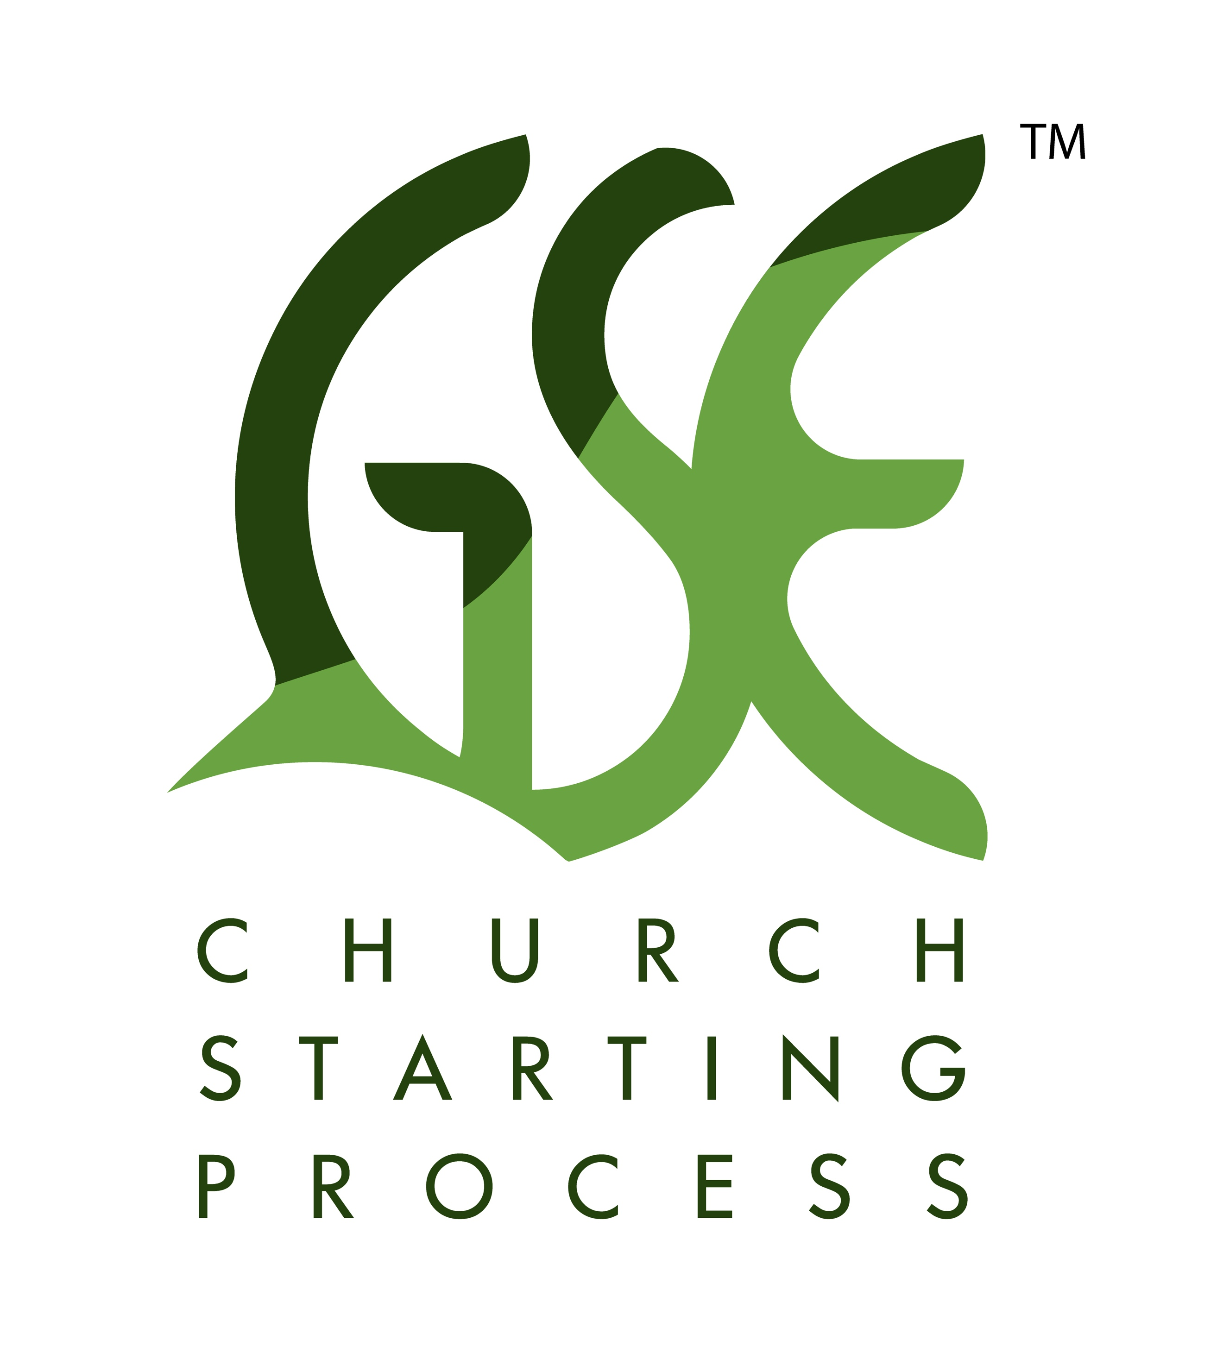
201 – GSE Multiply Student Notes

In our 201 GSE Multiply class, we focus on ‘non-addition’ or ‘non-adding’ thinking in regional church planting development. We are focusing our energy on our regions with intentional, multiplication drive.

Our desired outcomes from this training are:

1. Expand our network with new and original work on GSE concepts.

2. Build upon and improve existing GSE concepts.

3. Invest more in evaluating our regions and their movement ahead.

4. Based on this evaluation; intentionally target regional growth.

Q: As you think about planting churches in the USA, describe for me what you see in your world as it relates to new churches starting? How would you best describe it?

Q: What is currently blocking us from seeing multiplication, true multiplication in the USA today?

To help us achieve these outcomes, we look at four topics:

1. All our regions runs at ‘the speed of trust.’ How can we best do this? How do we build that trust?

2. Intentional focus on regional church planting. How can we engage more? What are steps that we can take to move the gospel to places my local church does not reach?

3. Exploration of key and careful partnership building in your region. What does these partnerships look like? How do I build key partnerships, trans-denominational partnerships?

4. Coaching – the need to coach in your region and train coaching. In our network, we build around two key pillars: GSE ideas and non-directive coaching. How can we best do this?

Q: Since we are having things happen at the speed of trust; how do we build this kind of trust among people in our regions?

1. All our regions runs at ‘the speed of trust.’ How can we best do this?

Stephen Covey’s The Speed of Trust:

“The ability to establish, grow, extend, and restore trust with all stakeholders – customers, business partners, investors, and coworkers – is the key leadership competency of the new global economy.” P. 21

“Trust is the function of two things: character and competence.” P. 30

“Leadership is getting results in a way that inspires trust.” P. 40

The best time to plant a tree is twenty years ago. The second-best time is today. – Chinese Proverb P. 36.

Covey’s Five Waves of Trust:

1. The first wave: Self Trust
This deals with the confidence we have in ourselves.
Q: Do I trust myself? Am I someone others can trust?

Cores: 1. Integrity (character); 2. Intent; 3. Capabilities; 4. Results (last 3 = competence)

2. The second wave: Relationship Trust
This deals with how we establish and increase ‘trust accounts’ with others.

13 Behaviors: 1. Talk straight; 2. Demonstrate respect; 3. Create transparency; 4. Right wrongs; 5. Show loyalty; 6. Deliver results; 7. Get better; 8. Confront reality; 9. Clarify expectations; 10. Practice accountability; 11. Listen first; 12. Keep commitments; 13. Extend trust

3. The third wave: Organizational Trust
This deals with how leaders can generate trust in all kinds of organizations . . .

4. The fourth wave: Market Trust
This deals with the level at which almost everyone clearly understands the impact of trust; this focuses on reputation.

5. The fifth wave: Societal Trust
This deals with creating value for others and for society at large.

Solomon and Flores, Building Trust

“In that time (of the authors consulting for decades with companies), the problem of trust has clearly emerged as the problem in human relationships and organizations.” P. ix

“Trust is something that must be learned.” P. 9

“The German sociologist Niklas Luhmann stresses that trust is a way of dealing with complexity in an increasingly complex society. There is a dep truth to this. The paradigm of trust is not found in the simplicity of a familiar relationship. Rather, it exists in the new complexity of the world and global economy. Trust not only lets us increase complexity in our lives (and thus simplify them at the same time); it also changes our lives in dramatic ways, allowing us to explore in new directions, to experiment and express ourselves in our relationships in ways that would otherwise be unthinkable. (emphasis added) P. 9

Simple trust: “Simple trust is the kind of trust that most of us, most of the time, take as our paradigm. It consists primarily of basic trust, unthinking trust in our essential security, in the benign indifference if not the benevolence of our fellow citizens. . .” P. 60

Authentic trust: “Authentic trust, as opposed to simple and bind trust, does not exclude or deny distrust, but rather accepts it and goes on to transcend it in action. One might even say that authentic trust embraces distrust and involves the willful overcoming of it, not just a matter of attitude but as a matter of practical interaction. . .

…because trusting changes both the person trusted and the person who trusts. Trusting is a choice, a decision, and authentic trusting takes into primary account the way that relationship will change as the result of that choice.” P. 94-95

Our plan for building trust:

55x peitho occurs – the focus is how peitho means “persuade by trust” – “achieve trust” or because of trust:

*The word often refers to the fruit or outcome of someone’s work – Acts 5:33-39; 17:4; 18:4, 13; 19:8, 26; 21:14; 26:28; 28:23

*Word shows the clearly foundational realm we are talking about: Romans 8:38; 2 Cor 1:9; Phil 1:6; Heb 13:17-18

For our purposes, from this peitho study, our actions plan to move ahead in ‘moving at the speed of trust’ is this:

For us, to build trust in regions:

How can I best help those around me

1) I need to be intentional in building trust - Luke 16:19-31: As the story of the Rich man and Lazarus unfolds, Luke 16:29 becomes central to the point Jesus is making. In this verse:

“But Abraham said, ‘They have Moses and the Prophets; let them hear them.” (NASB)

We see Jesus’ focus – people have God’s word and the option to ‘hear’ it. In Hebrew culture, if you do what you ‘hear,’ then you have “heard it.” When you do not do what you have ‘heard,’ then you “have not heard it.”

These two ideas are key: Having and Hearing (and thus doing).

I can build trust relationships via Having and Hearing – (Luke 16:19-31 – peitho used in v. 31.)

Convincing people is the point; helping them “become or have Jesus” and “do” what He wants is the pont. The solution: 1. Having – v. 29; 2. Hearing – v. 31

Or: 1. Having – being toward God; 2. Hearing – doing Jesus mission/gospel.

2) There is great value in building trust – asking what drives me is key? Seeing the Treasure – Jesus’ mission - 2 Tim 1:12-14:

v. 12: “For this reason, I suffer these things, but I am not ashamed; for I know in Whom I am trusting and I am completely persuaded (peitho) that He is able to guard my treasure (paratheke) stored for that day when He returns for us.
V. 13: I need you to have the healthy standard of the words you have heard from me in faith and love in Jesus Christ.
V. 14: You (singular) guard your good treasure (paratheke) through the Holy Spirit who is personally indwelling you. (Tony’s Translation)

*There is a ‘treasure’ that I give to Jesus to hold until I see him and there is a treasure He gives to me to guard.

See Raising Rabbits p. 165 ff for more on this.

-paratheke is what kept Paul and Timothy going; this word used to describe the most important of what is important; What drives you all the time;

3) I have great motivation in building trust – I care about people - 2 Cor 5:1-11:

v. 1-6 we are prepared/preparing for eternity;
v. 7-9: Therefore we please Jesus!;
v. 10 phaneroo happens first of 3x – bema;
v. 11 – persuading (peitho) mankind because of this fear of what is coming was key to Paul and needs to be key for us.

4) People are worth investing in to see trust built, but I am dealing with my heart’s doubts - 1 John 3:19

Point: I can doubt! Especially when it comes to loving people and caring for people; God is bigger than my heart, but I need help – so I need to work at persuading myself; let God’s truth persuade me to His mission

GSE Results/Storytelling + Relationship + Coaching = Trust Building

2. Intentional focus on regional church planting. How can we engage more?

In processing a geographic region using GSE, focus on these things:

1) GSE ideas and non-directive coaching

2) These ideas:

1. There are at least two options when it comes to beginning all this regionally:

1) Begin with early adopters/innovators to do GSE - for both planting and working with established churches

2) Begin with early mid adopters (early majority) - discover/see a regional leader and ‘convince’ them to lead in this - then equip them to take this forward in both GSE use in starting churches and working in the established church.
-this pathway is/can be slower in developing
-embrace trusted leaders
-keep the group small
-use GSE licensing concept
-focus on changing the thinking in the local church, at least some in local church, enough to begin tipping point and move ahead from there

2. Raise up/identify at least the regional leader and begin coaching relationship

3. Do GSE in region - in person and on line - all 3 levels plus and coaching

4. Open IC conversation

5. Through presence and measured fruit; bring mid adopters on board

6. Use mid adopter concepts to communicate

7. Form and engage a GSE Team focus

8. Explore regional elders/eldership from oversight and vision perspective/regional focus viewpoint

9. De-silo the conversation about Jesus’ mission!

3) Use the GSE Regional Pathway Tool

Other thoughts:

-Lead your region to start churches while building your GSE regional team.

-Partner with others in your region to start churches. Other denominations and networks.

-Work hard to take advantage of what the HS is doing in your region – listen well.

-Be open to minimal training times – just enough to get started.

Q: What are you doing to intentionally start new GSE processed churches?

Q: Based on where you are at geographically, what are your biggest needs when it comes to starting GSE processed churches?

3. Exploration of key and careful partnership building in your region. What do these partnerships look like?

-Listen to your partner(s) to know what is going on in your region.

-Allow regional leaders to train as they can – listen carefully.

-Take ‘second chair’ when at all possible.

-Stay focused on your regional leaders and team building.

-Do not allow any partnerships to slow you down or stop you from ‘one a day.’ Wait on no one, nor give ‘power’ or ‘decision making’ authority to anyone not already a key part.

-Allow regional leaders to ‘self-select’ into the regional leader role.

-As you form a GSE regional team, the G has the last say.

-Role of evaluating my time on Jesus’ clock:

Paul has concern about ‘running in vain’ or wasting time ministry wise – how does that impact our conversation?

See:

*2 Corinthians 6:2

*Galatians 2:2

*Philippians 2:16

*1 Thessalonians 3:5

4. Coaching – the need to coach in your region and train coaching. How can we best do this?

-You need to coach in your region.

-Make sure you have a coach.

-We need to do coach training in your region.

-Take 103 GSE Coach training.

What is Coaching?
-It is an excellent way to develop and disciple people in Jesus Christ. It builds the intrinisic motivation side of people.

-It is a question asking process that is dependent on the Holy Spirit leading the process for both the coach and client.

-It is a process based on a ‘generosity posture.’

“If God alone is producing Church Planting Movements, then God alone is to blame when there are no Church Planting Movements.” David Garrison, Church Planting Movements, p. 26

“So the churches were being strengthened in the faith, and were increasing in number daily.” Acts 16:5 (NASB)

